Business Intelligence Strategy Report

1. Purpose and Importance:

Organizations now focus on ways to use operational data to support decision-making in order to assist in decision making to gain a competitive advantage. The problem with this issue is operational systems were not designed for analytics. Data Warehouses were created to support this function by collecting data from multiple operational data sources to be analyzed for presentation. Data Warehousing is defined by Bill Inmon as “A subject-oriented, integrated, time-variant, and non-volatile collection of data in support of management’s decision-making process (Inmon, 1993).” Subject-oriented data includes the fundamentals of the enterprise the data into data mods including customers, products, sales, employee, etc. Integrated data corporates application-oriented data from different data source systems. Time-variant data is valid at only some point or an interval over time. The data can represent a series of snapshots. Non-volatile data is typically not updated in real-time but refreshed upon operational systems with new data to supplement, not replace.

What is the ETL process? ETL stands for extraction transformation loading. Extraction targets one or more data sources including databases, spreadsheets, enterprise resource planning, and web usage log files. Transformation is a set of rules or functions to the extracted data which will determine how it will be analyzed. Transformations may include data summations, data encoding, data merging, data splitting, data calculations, and creation of surrogate keys. Loading involves adding constraints such as uniqueness, referential integrity, and mandatory fields which will contribute to the overall data quality. Business intelligence tools (BI tools) are a way for companies to monitor data and generate business insights. These tools are necessary components in making smarter, better decisions that drive results.

1. Opportunities and Benefits:

Senior management may realize the data unpresentable in their systems holds a value to the company but what is that value or benefit? The benefits of Data Warehousing include the following:

* Potential high returns on investments
* Competitive advantage
* Increased productivity of corporate decision-makers
* Quick and easy access to data
* Data quality and consistency

Decision makers may question the difference between an operational system or also named On-Line Transaction Processing (OLTP) and Data Warehousing or also named On-Line Analytical Processing (OLAP). The illustration below shows the difference between the two.

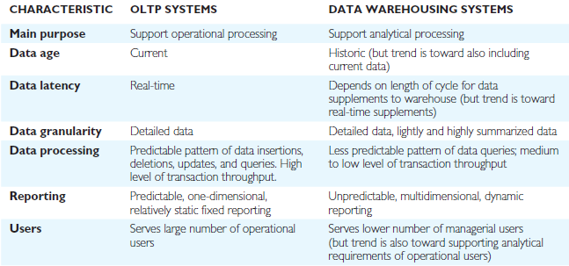

1. Associated Technologies

New technologies have been starting to implement the challenges of data volume and the speed the information is delivered. The two associated technologies are “Data Warehouse Appliance” and “In memory database systems”. Data Warehouse Appliance (DWA) includes an integrated set of servers, storage, operating system(s), and Data Base Management System. “Shared everything” architecture known as Symmetric Multi Processing (SMP) and “Shared nothing” architecture is known as Massively Parallel Processing (MPP). MPP has its own dedicated memory and operating system. Frequently used data is stored in Solid State Drive (SSD) which is speculated to be 22 times faster in random data reads and response. Less frequent data are stored in Hard Disk Drive (HHD) which is not as fast as the SSD. Together the process creates an increased process time and adequate memory. The figure below shows the difference between the two.

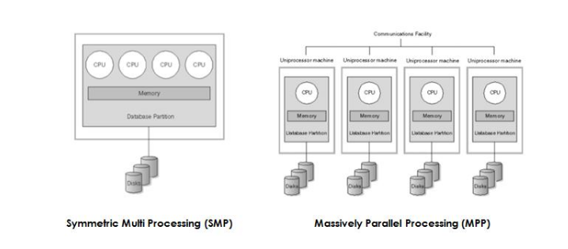

In-memory database (IMDB) primarily relies on main memory for computer data storage, contrasted with DBMS employing a disk storage mechanism. Main memory databases are faster than disk-optimized databases since internal optimization algorithms are less complex and execute fewer CPU instructions. Accessing data in memory decreases the time querying data and eliminates the need for creating indexes, aggregates, and designing of cubes and star schemas. Data access is improved from 10,000 to 1,000,000 times faster than from disk minimizing the need for performance maintenance by IT staff and faster results for end user tools.

1. Commercial Products

Many commercial products exist to manage data efficiently and effectively. Popular Data Warehouse Appliance (DWA) products include Oracle Exadata and Exalytics, IBM Netezza, Teradata, and SAP HANA. Popular In-memory database (IMDB) products include Oracle - Times ten in memory db 11g – database, SAP HANA (Both DWA & IMDB), IBM DB2 BLU-Database, and SQL Server 2014. The cost of these applications varies based on number of users, Tera-Byte used, and cores used in server.

1. Problems and Issues

Data Warehousing can be extremely beneficial as documented in previous sections of the report. Problems and issues do exist which are listed below:

* Underestimation of resources for data loading
* Hidden problems with source systems
* Required data not captured
* Increased end-user demands
* Data homogenization
* High demand for resources
* Data ownership
* High maintenance
* Long duration projects
* Complexity and integration

Data Marts can be created to resolve many of the issues. A Data Mart is subset of corporate data to support analytical requirements of a particular business unit. The reason Data Marts are in place is to eliminate the congestion of irrelevant data to different departments of a business and speed up the analytical end user business process.

1. Emerging Trends

The emerging trends and technologies in Business Intelligence can be defined as the Data Warehouse Appliance (DWA) and In-memory database (IMDB) discussed in Associated Technologies section of the report. Example of Oracle’s engineered system shown on the next page.

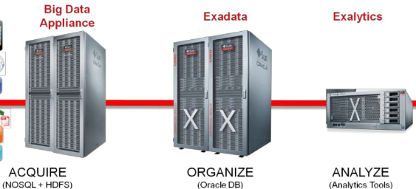

Works Cited:

<http://www.slideshare.net/gharriso/five-database-trends>

<https://www.linkedin.com/pulse/20141206055904-21128223-emerging-technologies-in-data-warehousing-business-intelligence>

Database Systems; A Practical Approach to Design, Implementation, and management. Thomas Connolly and Carolyn Begg. 6th Edition PEARSON